2420030120
SECTION 11
SHAIK ALIZA SAMREEN
Experiment 1: Case Study
Problem Statement: Develop an Enterprise Resource Planning (ERP) System for a university to manage student records, faculty information, attendance, examinations, fee payments, and academic activities through a centralized platform. Real-World case study an online shopping platform
1. Functional Requirements
Student
- Register/Login
- View Profile
- View Attendance
- View Timetable
- View Examination Results
- Pay Fees Online
- Download Hall Ticket
- View Notifications
Faculty
- Login
- Mark Attendance
- Upload Marks
- Upload Study Materials
- Manage Student Records
- View Timetable
Admin
- Manage Students
- Manage Faculty
- Manage Courses
- Generate Reports
- Manage Fee Details
- Manage Examination Schedule

2. User Stories
User ID | User Story |  |  | Priority
US-01 | As a student, I want to register so that I can access the ERP portal. |  |  | High
US-02 | As a student, I want to log in securely. |  |  | High
US-03 | As a student, I want to view my attendance. |  |  | High
US-04 | As a student, I want to check my examination results. |  |  | High
US-05 | As a student, I want to pay my fees online. |  |  | Medium
US-06 | As a faculty member, I want to upload student marks. |  |  | High
US-07 | As a faculty member, I want to mark attendance. |  |  | High
US-08 | As an admin, I want to manage student records. |  |  | High
US-09 | As an admin, I want to manage faculty records. |  |  | Medium
US-10 | As an admin, I want to generate academic reports. |  |  | Medium
3. Selected Software Development Process Model
Agile Scrum
Reason for Selection
- Continuous improvement
- Easy to manage changing requirements
- Regular feedback from users
- Faster feature delivery
- Suitable for enterprise applications

Sprint Plan
Sprint | Features
Sprint 1 | Student Registration & Login
Sprint 2 | Student Dashboard
Sprint 3 | Attendance Management
Sprint 4 | Examination Module
Sprint 5 | Fee Payment Module
Sprint 6 | Faculty & Admin Module
Sprint 7 | Testing & Deployment

4. Programming Language Selection
Backend
- Java (Spring Boot)
Reasons
- Secure
- Scalable
- Enterprise-level applications
- REST API support
- Excellent database connectivity
Frontend
- HTML5
- CSS3
- JavaScript
- React.js

Database
- MySQL
Other Technologies
- REST API
- JWT Authentication
- Git
- Docker
- AWS Cloud

5. System Architecture
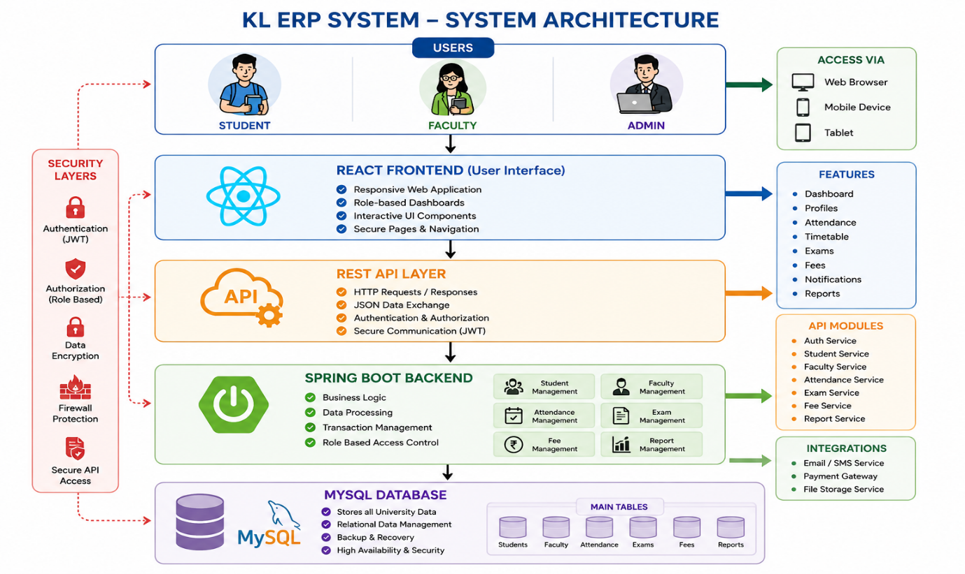

6. Implementation Strategy
Phase 1 – Requirement Analysis
- Gather university requirements
- Prepare SRS
- Identify user roles
Phase 2 – System Design
- Database Design
- UI Design
- UML Diagrams
- Architecture Design
Phase 3 – Development
- Authentication
- Attendance Module
- Examination Module
- Fee Module
- Admin Module
Phase 4 – Testing
- Unit Testing
- Integration Testing
- System Testing
- User Acceptance Testing
Phase 5 – Deployment
- Docker
- AWS EC2
- MySQL
- Nginx

7. Evaluation Strategy
Evaluation Parameter | Method
Functional Accuracy | Requirement Verification
Performance | Load Testing
Security | Authentication Testing
Reliability | Continuous Monitoring
Usability | User Feedback
Scalability | Multiple User Testing
Maintainability | Code Review

8. Expected Outcomes
- Centralized university management
- Faster attendance management
- Secure student records
- Easy fee payment
- Accurate examination management
- Better communication
- Improved academic efficiency

